TEAMDUTY Web-application

Software Design Document

By

Mr. Manuchet Manoi 542115049
Mr. Saknarong Noipaksa 542115061

Department of Software Engineering
College of Arts, Media and Technology
Chiang Mai University

Project Advisor

______________________________________

Aj. Jayakrit Hirisajja

Document History
Document Name | Version | Status | Date | Viewable | Reviewer |  | Responsible
Documents
TEAMDUTY - Web application – SDD v 0.1.docx | Add Chapter 1  - Objective  - Intended Audience and Reading Suggestions  - Project Scope | Draft | 01 May 2014 | MM,  SN,JH |  | MM,  SN | MM,  SN
TEAMDUTY - Web application - SDD v 0.2.docx | Add Chapter 2  Add Chapter 3 | Draft | 01 May 2014 | MM,  SN,JH |  | MM,  SN | MM,  SN
TEAMDUTY - Web application - SDD v 0.3.docx | Add Chapter 4  - Class Diagram  - Class Diagram Description  - Sequence Diagram | Draft | 24 May 2014 | MM,  SN,JH |  | MM,  SN | MM,  SN
TEAMDUTY - Web application - SDD v 0.4.docx | Add Chapter 5  - ER Diagram  - DB Design  Add Chapter 6  - User Interface Design | Draft | 16 June 2014 | MM,  SN,JH |  | MM,  SN | MM,  SN
TEAMDUTY - Web application - SDD v 0.5.docx | Adjust Chapter 4  - Add more Class Diagram  - Add more Class Diagram Description  - Add more Sequence Diagram  Adjust Chapter 5  - Change ER Diagram  - Change DB Design  Adjust Chapter 6  - Adjust User Interface Design | Draft | 06 July 2014 | MM,  SN,JH |  | MM,  SN | MM,  SN
TEAMDUTY - Web application - SDD v 1.0.docx | Adjust Chapter 6  - Adjust User Interface Design  Adjust Chapter 5  - Change ER Diagram  - Change DB Design | Draft | 21 July 2014 | MM,  SN,JH |  | MM,  SN | MM,  SN
TEAMDUTY - Web application - SDD v 2.0.docx | Adjust Chapter 6  - Adjust User Interface Design  Adjust Chapter 5  - Change ER Diagram  - Change DB Design | Draft | 19 July 2014 | MM,  SN,JH |  | MM,  SN | MM,  SN

*MM = Manuchet Manoi
*SN = Saknarong Noipaksa
*JH = Jayakrit Hirisajja

Table of Contents

Chapter One | Introduction 4
1.1 Objective 4
1.2 Intended Audience and Reading Suggestions 4
1.3 Project Scope 4
Chapter Two | System Overview 5
Chapter Three | Detail Design 6
3.1 Class Diagram 6
3.1.1 Controller Package Class 6
3.1.2 Repository Package Class 7
4.1.3 Model Class 8
3.2 Class Diagram Description 10
3.2.1 Controller Class Description 10
3.2.2 Repository Class Description 16
3.2.3 Model Class Description 24
3.3 Sequence Diagram 29
service request customer 29
freelancer supply 39
Chapter Four | Data Architecture 45
4.1 ER Diagram 45
4.2 DB Design 46
Chapter Five | User Interface Design 49

Chapter One | Introduction

Objective
The Objective of this (SDD) Software Design Document is establish design for TEAMDUTY Web application and show all of program design and data of TEAMDUTY Web application. And this Software Design Document is guidelines for develop software correctly .This Software Design Document is contains with a complete description of the design system for developer can develop TEAMDUTY Web application.

Intended Audience and Reading Suggestions
This Software Design Document documentation is intended to be used for anyone that relate with TEAMDUTY Web application. The documentation will benefit to those who develop the system and those who use the system followed:
Development team
- The Software Design Document can be present architecture within software product
- The Software Design Document can be coordinate a development team under a single vision.
- The Software Design Document help development team know roughly semblance of program
- The Software Design Document can be help development team know information within program before develop
User
- The Software Design Document can be help User know roughly semblance of program
- The Software Design Document can be help User to know flow event to use software product

Project Scope
The scope of this software design document is strategies to establish the system that:
- The Software System is Web-application.
- The Software System provide only software side.
- The Software System divide to two main part of user that is software human resource, and software job auction project.
- Show requirement and detail of Software system
TEAMDUTY – web application is a website application. This will provide a system to manage about software freelance finding job software human resource.

Chapter Two | System Overview

TEAMDUTY Web application on both of two progress is consisting of five past of feature that is Account management system and Service request customer management system
First, Account management system is past of system to provide both of Freelance Supply and Service request customer to Register ,ConfirmRegister to be member ,Login to using system and adjust about their profile to show to other user within system.
Second, Service Request customer management system is past of system to provide Service Request Customer to post project, view other project within system and view list of freelancer that come to bid project and show detail in each bidding as Freelancer that come to bidding, bid detail and budget to use in each bid.
Third, Search system is past of system to provide both of Service request customer and Freelancer supply find interest word to be alternative to select Job, or project participants this system will provide User Interface that help both of user easier to find interest thing on Web-application.
Fourth, Freelancer supply system is past of system to provide both of Freelancer supply request interest from job that posted by employer. And notification that appropriate with freelancer supply and made it easier for freelancer to find a job on web application.
Fifth , Commutation system that is past of system to provide both Freelancer supply and Service request customer find accept to work in project process management together Service request customer can check progress of work in this past. and Freelancer supply can display progress of project in this path too.
That is all for phase 2 .we will separated Software Design Document into 3 phase follow that
Submit for | Software Design and Architectures of-
Progress1 | Feature 1 # Account Management System  Feature 2 # Service request customer management system.
Progress2 | Feature 3 # Search system  Feature 4 # Software-freelance supply management system  Feature 5 # Communication system
Showpro | Feature 6 # Verification system  Feature 7 # Administrator Management system

Chapter Three | Detail Design

3.1 Class Diagram

3.1.1 Controller Package Class
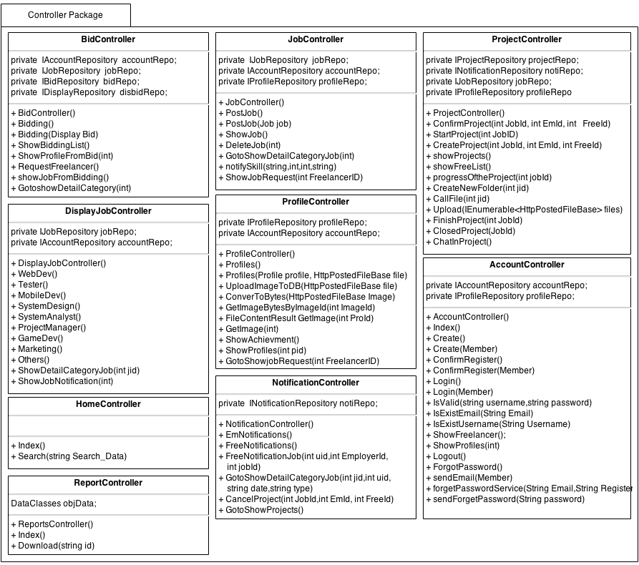
This class diagram will be show Method and attribute in each class only progress 1 + progress 2

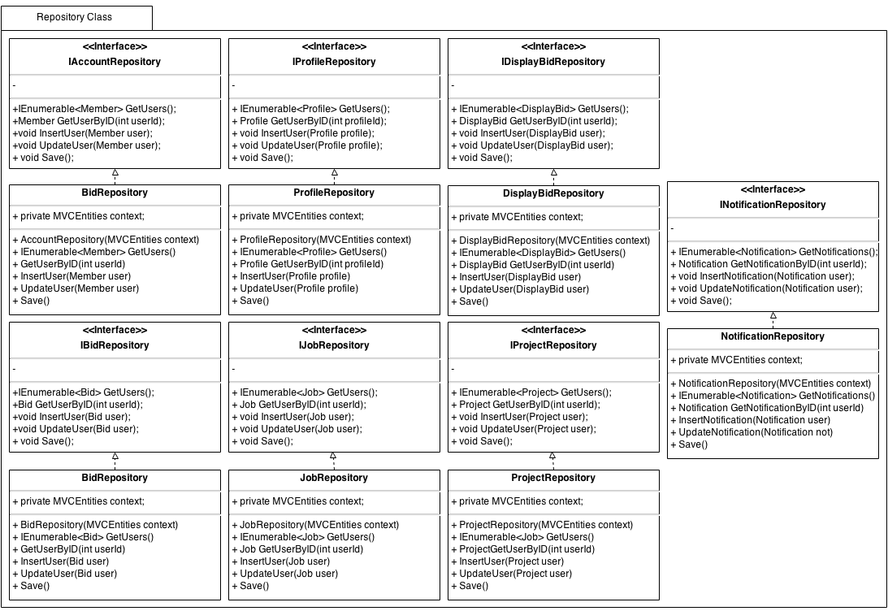
3.1.2 Repository Package Class

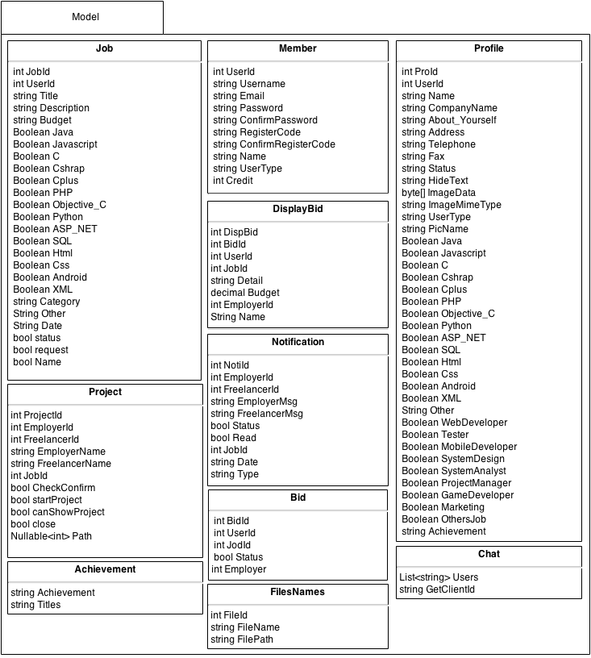
3.1.3 Model Class
TEAMDUTY – ClassDiagram Phase2

3.2 Class Diagram Description
This class diagram Description will be show Method and attribute in each class only progress1

3.2.1 Controller Class Description
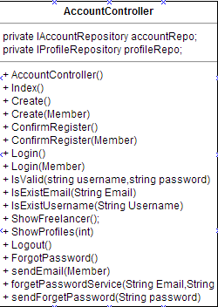

Property
ID | Name | Description | Remark
1 | accountRepo | Variable that build to call IAccountRepository Object in this class | Type: IAccountRepository object
2 | profileRepo | Variable that build to call IProfileRepository Object in this class | Type: IProfileRepository object

Methods
ID | Name | Description | Remark
1 | Index() | The system call this method to show text list of User | returnType:View(user)  Parameter:-
2 | AccountController() | The System use this method to call object from Repository | returnType:  Parameter:
3 | Create(Member member) | The System use this method to insert member into database,identify type of user and send link to Email | returnType: RedirectToAction("Index", "Home");  Parameter: member
4 | ConfirmRegister(Member member) | The System use this method to ConfirmRegister again  and insert other user information to register. | returnType: RedirectToAction("Index", "Home");  Parameter:member
5 | Login(Member member) | The system use this method identify user to using web application | returnType: RedirectToAction("Index", "Home");  Parameter:member
6 | IsValid(String username,String password) | The system use this method check username and password that log-in  found in database list or not. | returnType:bool  Parameter: String username, String password
7 | IsExistEmail(String Email) | The system use this method check Email that Register Exist in database or not | returnType:bool  Parameter: String Email
8 | IsExistUsername(String Username) | The system use this method check Username that Register Exist in database or not | returnType:bool  Parameter: String Username
9 | ShowFreelancer() | The system call this method to show list of Freelancer in system | returnType: View(users);  Parameter:
10 | ShowProfiles(int) | The system use this method o show profile of Freelnacer | returnType: RedirectToAction("ShowProfiles", "Profile", new { pid = id });  Parameter:-
11 | forgetPassword() | The system use metjod to call forgetpassword view page | returnType:  Parameter:-
12 | sendEmail() | The system use this method to send email to user. | returnType:  Parameter:-
13 | forgetPasswordServoce(String Email,RegisterCode) | The system use this method to receive Email & RegisterCode and validate them | returnType:  Parameter: String Email,String RegisterCode
14 | SendForgetPassword(String Password) | The system use this methed to send password to email that user forgot | returnType:  Parameter:-
15 | Logout() | The system use this method to logout | returnType: RedirectToAction("index", "Home");  Parameter:-
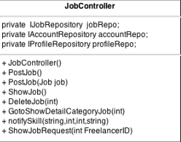
Property
ID | Name | Description | Remark
1 | jobRepo | Variable that build to call IJobRepository Object in this class | Type: IJobRepository object
2 | accountRepo | Variable that build to call IAccountRepository Object in this class | Type: IAccountRepository object
3 | profileRepo | Variable that build to call IProfileRepository Object in this class | Type: IProfileRepository object
3 | notiRepo | Variable that build to call INotificationRepository Object in this class | Type: INotificationRepository object

Methods
ID | Name | Description | Remark
1 | JobController() | The System use this method to call object from Repository | returnType: -  Parameter: -
2 | PostJob(Job job) | The system use method to insert job information  To database | returnType: View();  Parameter: Job Object
3 | ShowJob() | The system use this method to Show list of job in  database | returnType: View(jobs);  Parameter:-
4 | DeleteJob(int id) | The system use this method to delete job by use jobid | returnType: -  Parameter: int id
5 | GotoShowDetailCategoryJob(int jid) | The system use this method to showjobDetail by use jobid | returnType: -  Parameter: int jid
6 | NotifySkill(string OtherSkills,int EmployerId,int JobId,string Date) | The system use this method to Validate skill and show Employerid ,jobid and Date | returnType: -  Parameter: string OtherSkills,int EmployerId,int JobId,string Date
7 | showJobRequest (int FreelanceId) | The system use this method to ShowJobRequest by use FreelancerId | returnType: View(jobs)  Parameter: int FreelanceId

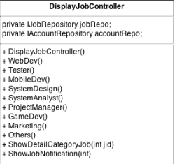

Property
ID | Name | Description | Remark
1 | jobRepo | Variable that build to call IJobRepository Object in this class | Type: IJobRepository object
2 | accountRepo | Variable that build to call IAccountRepository Object in this class | Type: IAccountRepository object
2 | projRepo | Variable that build to call IProjectRepository Object in this class | Type: IProjectRepository object

Methods
ID | Name | Description | Remark
1 | DisplayJobController() | The System use this method to call object from Repository | returnType: View("CategoryJob", jobs);  Parameter:
2 | WebDev() | The system use this method to display job of WebDeveloper Page | returnType: View("CategoryJob", jobs);  Parameter:
3 | Tester() | The system use this method to display job of  Tester Page | returnType: View("CategoryJob", jobs);  Parameter:
4 | MobileDev() | The system use this method to display job of MobileDeveloper Page | returnType: View("CategoryJob", jobs);  Parameter:
5 | SystemDesign() | The system use this method to display job of SystemDesign Page | returnType: View("CategoryJob", jobs);  Parameter:
6 | SystemAnalyst() | The system use this method to display job of SystemAnalyst Page | returnType: View("CategoryJob", jobs);  Parameter:
7 | ProjectManager() | The system use this method to display job of  Project manager Page | returnType: View("CategoryJob", jobs);  Parameter:
8 | GameDev() | The system use this method to display job of GameDeveloper Page | returnType: View("CategoryJob", jobs);  Parameter:
9 | Marketing() | The system use this method to display job of Software MarketingPage | returnType: View("CategoryJob", jobs);  Parameter:
10 | Other() | The system use this method to display job of other software role job Page | returnType: View("CategoryJob", jobs);  Parameter:
11 | ShowDetailCategoryJob(int jid) | The system use this method to display detail in each job of every software role job Page | returnType: PartialView("ShowDetailCategoryJob",JobModel);  Parameter:int jid
12 | ShowJobNotification(int jid) | The system use this method to ShowJobNotification by using jid(Jobid) | returnType: View("ShowJobNotification", JobModel);  Parameter:int jid
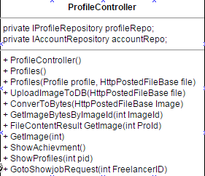
Property
ID | Name | Description | Remark
1 | profileRepo | Variable that build to call IProfileRepository Object in this class | Type: IProfileRepository object
2 | accountRepo | Variable that build to call IAccountRepository Object in this class | Type: IAccountRepository object
3 | jobRepo | Variable that build to call IJobRepository Object in this class | Type: IJobRepository object

Methods
ID | Name | Description | Remark
1 | ProfileController() | The System use this method to call object from Repository | returnType:  Parameter: -
2 | Profiles(Profile profile, HttpPostedFileBase file) | The System use this method to retrieve profile of user | returnType: RedirectToAction("Index", "Home");  Parameter:profile object, HttpPostedFileBase object
3 | UploadImageToDB(HttpPostedFileBase file) | The System use this method to upload image to database | returnType:  Parameter: HttpPostedFileBase object
4 | ConverToBytes(HttpPostedFileBase file) | The System use this method convert type of picture to byte | returnType: imageBytes  Parameter: HttpPostedFileBase Image
5 | GetImageBytesByImageId(int ImageId) | The System use this method to find image in database list | returnType:  Parameter: int ImageId
6 | FileContentResultGetImage(int Proid) | The System use this method to get image to profile id | returnType: new FileContentResult(byteArray, "image/jpeg");  Parameter: int Proid
7 | ShowProfiles(int pid) | The System use this method to show profile | returnType: View(usersProfile)  Parameter: int pid
8 | GotoShowjobRequest(int FreelanceId) | The System use this method to showjobRequest Page by using FrelancerId | returnType: RedirectToAction("showJobRequest", "Job", new { FreelanceId = FreelanceId });  Parameter: int FreelancerId
9 | ShowAchievment() | The System use this method to display title of job that freelancer done | returnType: PartialView("ShowAchievement", achievement);  Parameter:
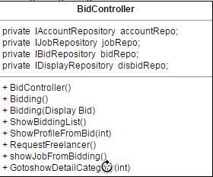
Property
ID | Name | Description | Remark
1 | accountRepo | Variable that build to call IAccountRepository Object in this class | Type: IAccountRepository object
2 | jobRepo | Variable that build to call IJobRepository Object in this class | Type: IJobRepository object
3 | bidRepo | Variable that build to call IBidRepository Object in this class | Type: IBidRepository object
4 | disbidRepo | Variable that build to call IDisplayBidRepository Object in this class | Type: IDispalyBidRepository object

Methods
ID | Name | Description | Remark
1 | ProfileController() | The System use this method to call object from Repository | returnType:  Parameter:
2 | Bidding() | The system use this method to create View to Display | returnType: PartialView("Bidding");  Parameter:
3 | Bidding(DisplayBid disbid) | The System use this method to add BidInformation to database | returnType: PartialView("Bidding");  Parameter: DisplayBid disbid
4 | showBiddingList() | The System use this method to show bidder in project | returnType: PartialView("showBiddingList", bids);  Parameter:
5 | ShowProfilesFromBid(int id) | The System use this method link to profile of bidder | returnType: RedirectToAction("ShowProfiles", "Profile", new { pid = id });  Parameter: int id
6 | RequestFreelancer() | The system use this method to request Freelancer | returnType: View("Bidding");  Parameter:
7 | showJobFromBidding() | The system use this method to Show list of Bid in each job | returnType: View(Bjobs);  Parameter:
8 | GotoShowDetailCategoryJob(int jid) | The system use this method to Show Bidding detail in showCategoryJob | returnType: RedirectToAction("ShowDetailCategoryJob", "DisplayJob", new { jid = jid });  Parameter:int jid
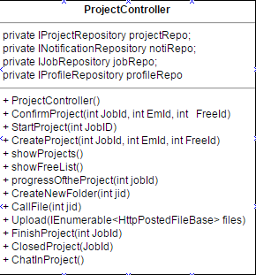
Property
ID | Name | Description | Remark
1 | projectRepo | Variable that build to call IProjectRepository Object in this class | Type: IProjectRepository object
2 | notiRepo | Variable that build to call INotificationRepository Object in this class | Type: INotificationRepository object
3 | jobRepo | Variable that build to call IJobRepository Object in this class | Type: IJobRepository object
4 | profileRepo | Variable that build to call IProfileRepository Object in this class | Type: IProfileRepository object

Methods
ID | Name | Description | Remark
1 | ProjectController() | The System use this method to call object from Repository | returnType:  Parameter:
2 | ConfirmProject(int JobId, int EmId, int FreeId) | The System use this method to confirm to do project | returnType:  Parameter: int JobId, int EmId, int FreeId
3 | StartProject(int JobID) | The System use this method to start project process management | returnType:  Parameter: int JobID
4 | ShowProject() | The System use this method to list of project that avaliable | returnType: View(Jobs);  Parameter:
5 | showFreeList() | The System use this method to | returnType:  Parameter:
6 | progressOftheProject(int jobId) | The System use this method to show projectManagement Page | returnType: View(proJs);  Parameter: int jobId
7 | CreateNewFolder(int jid) | The System use this method to create folder on server | returnType:  Parameter: int jid
8 | CallFile(int jid) | The System use this method to set mappath of folder | returnType:  Parameter: int jid
9 | Upload(IEnumerable<HttpPostedFileBase> files) | The System use this method to uploadfile to server | returnType: RedirectToAction("progressOftheProject", "Project", new { JobId = JobId });  Parameter: IEnumerable<HttpPostedFileBase> files
10 | FinishProject(int JobId) | The System use this method to Finish project | returnType:  Parameter: int JobId
11 | ClosedProject(int JobId) | The System use this method to closed project | returnType:  Parameter: int JobId
12 | ChatInProject() | The System use this method to call chat on HTML page (JS) | returnType:  Parameter: PartialView("ChatInProject");

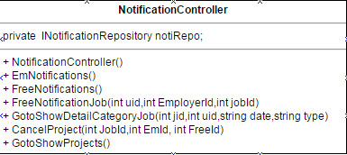
Property
ID | Name | Description | Remark
1 | notiRepo | Variable that build to call INotificationRepository Object in this class | Type: INotificationRepository object

Methods
ID | Name | Description | Remark
1 | NotificationController() | The System use this method to call object from Repository | returnType:  Parameter:
2 | EmNotifications() | The system use this method to showjob in Notification Page for Employer type | returnType: View(Notis);  Parameter:
3 | FreeNotification() | The system use this method to showjob in Notification Page for Freelancer type | returnType: View(Notis);  Parameter:
4 | FreeNotificationJob(int uid,int EmployerId,int jobid) | The System use this method to show request to do project from Employer | returnType:  Parameter: int uid,int EmployerId,int jobId
5 | GotoShowDetailCategoryJob(int jid,int uid,string date,string type) | The System use this method to detail of job that show in Notification Page | returnType:  RedirectToAction("ShowJobNotification", "DisplayJob", new { jid = jid });  Parameter:  int jid,int uid,string date,string type
6 | CancelProject(int JobId,int EmId, int FreeId) | The System use this method to cancel Project request | returnType:  Parameter:  int JobId,int EmId, int FreeId
7 | GotoShowProjects() | The System use this method to confirm to do the project | returnType  RedirectToAction("showProjects", "Project");  Parameter:

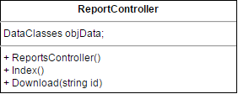
Property
ID | Name | Description | Remark
1 | objData | Model call that use for getfiles Includeing FileId ,Name or Path | Type: DataClasses object

Methods
ID | Name | Description | Remark
1 | ReportController() | The System use this method to call DataClasses object | returnType:  Parameter:
2 | Index () | The system use this method to define project process room , and get file in each room | returnType: PartialView(files);  Parameter:
3 | Download(string id) | The system use this method to downloadfile from server | returnType: File(filename, contentType,filename);  Parameter:
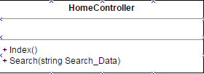

Methods
ID | Name | Description | Remark
1 | Index () | The system use this method to return index page of web application | returnType:  View();  Parameter:
2 | Search(string Search_Data) | The system use this method to search job | returnType: View(jobs.ToList());  Parameter: string Search_Data

3.2.2 Repository Class Description

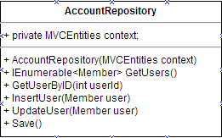
Property
ID | Name | Description | Remark
1 | context | Variable that build to call MVCEntities Object in this class | Type: MVCEntities object

Methods
ID | Name | Description | Remark
1 | AccountRepository(MVCEntities context) | The System use this method to call object from Database context | returnType:  Parameter:
2 | GetUsers() | The System use this method to get data from database | returnType: context.Members.ToList();  Parameter:
3 | InsertUser(Member user) | The System use this method to find data from database | returnType:  Parameter: Member user
4 | UpdateUser(Member user) | The System use this method to update data to database | returnType:  Parameter: Member user
5 | Save() | The System use this method to save data to database | returnType:  Parameter:
6 | GetUserByID(int userId) | The System use this method to find userId in database | returnType:  context.Members.Find(userId);  Parameter: int userId

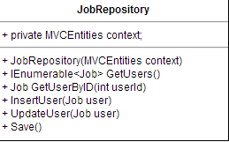

Property
ID | Name | Description | Remark
1 | context | Variable that build to call MVCEntities Object in this class | Type: MVCEntities object

Methods

ID | Name | Description | Remark
1 | JobRepository(MVCEntities context) | The System use this method to call object from Database context | returnType:  Parameter:
2 | GetUsers() | The System use this method to get data from database | returnType: context. Jobs.ToList();  Parameter:
3 | InsertUser(Job user) | The System use this method to find data from database | returnType:  Parameter: Job user
4 | UpdateUser(Job user) | The System use this method to update data to database | returnType:  Parameter: Job user
5 | Save() | The System use this method to save data to database | returnType:  Parameter:
6 | GetUserByID(int userId) | The System use this method to find userId in database | returnType:  context.Jobs.Find(userId);  Parameter: int userId

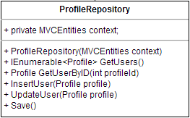
Property
ID | Name | Description | Remark
1 | context | Variable that build to call MVCEntities Object in this class | Type: MVCEntities object

Methods

ID | Name | Description | Remark
1 | ProfileRepository(MVCEntities context) | The System use this method to call object from Database context | returnType:  Parameter:
2 | GetUsers() | The System use this method to get data from database | returnType: context. Profiles.ToList();  Parameter:
3 | InsertUser(Profile profile) | The System use this method to find data from database | returnType:  Parameter: Profile profile
4 | UpdateUser(Profile profile) | The System use this method to update data to database | returnType:  Parameter: Profile profile
5 | Save() | The System use this method to save data to database | returnType:  Parameter:
6 | GetUserByID(int profileId) | The System use this method to find profileId in database | returnType:  context. Profiles.Find(profileId);  Parameter: int profileId

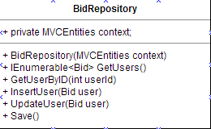
Property
ID | Name | Description | Remark
1 | context | Variable that build to call MVCEntities Object in this class | Type: MVCEntities object

Methods

ID | Name | Description | Remark
1 | BidRepository(MVCEntities context) | The System use this method to call object from Database context | returnType:  Parameter:
2 | GetUsers() | The System use this method to get data from database | returnType: context.Bids.ToList();  Parameter:
3 | InsertUser(Bid user) | The System use this method to find data from database | returnType:  Parameter: Bid user
4 | UpdateUser(Bid user) | The System use this method to update data to database | returnType:  Parameter: Bid user
5 | Save() | The System use this method to save data to database | returnType:  Parameter:
6 | GetUserByID(int userId) | The System use this method to find userId in database | returnType:  context.Bids.Find(userId); Parameter: int userId

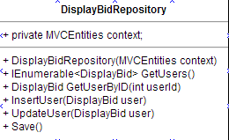
Property
ID | Name | Description | Remark
1 | context | Variable that build to call MVCEntities Object in this class | Type: MVCEntities object

Methods

ID | Name | Description | Remark
1 | DisplayBidRepository(MVCEntities context) | The System use this method to call object from Database context | returnType:  Parameter:
2 | GetUsers() | The System use this method to get data from database | returnType: return context.DisplayBids.ToList();  Parameter:
3 | InsertUser(DisplayBid user) | The System use this method to find data from database | returnType:  Parameter: DisplayBid user
4 | UpdateUser(DisplayBid user) | The System use this method to update data to database | returnType:  Parameter: DisplayBid user
5 | Save() | The System use this method to save data to database | returnType:  Parameter:
6 | GetUserByID(int userId) | The System use this method to find userId in database | returnType:  context.DisplayBids.Find(userId); Parameter: int userId

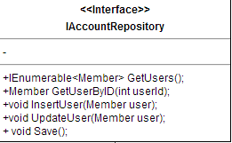
Methods
ID | Name | Description | Remark
1 | GetUsers() | The System use this method from Repository | returnType:  Parameter:
2 | InsertUser(Member user) | The System use this method from Repository | returnType:  Parameter: Member user
3 | UpdateUser(Member user) | The System use this method from Repository | returnType:  Parameter: Member user
4 | Save() | The System use this method from Repository | returnType:  Parameter:
5 | GetUserByID(int userId) | The System use this method from Repository | returnType:  Parameter: int userId

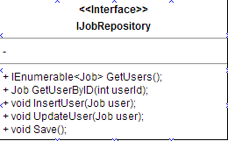

Methods
ID | Name | Description | Remark
1 | GetUsers() | The System use this method from Repository | returnType:  Parameter:
2 | InsertUser(Job user) | The System use this method from Repository | returnType:  Parameter: Job user
3 | UpdateUser(Job user) | The System use this method from Repository | returnType:  Parameter: Job user
4 | Save() | The System use this method from Repository | returnType:  Parameter:
5 | GetUserByID(int userId) | The System use this method from Repository | returnType:  Parameter: int userId

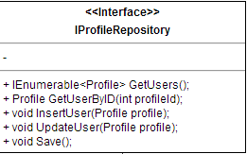
Methods
ID | Name | Description | Remark
1 | GetUsers() | The System use this method from Repository | returnType:  Parameter:
2 | InsertUser(Profile profile) | The System use this method from Repository | returnType:  Parameter: Profile profile
3 | UpdateUser(Profile profile) | The System use this method from Repository | returnType:  Parameter: Profile profile
4 | Save() | The System use this method from Repository | returnType:  Parameter:
5 | GetUserByID(int profileId) | The System use this method from Repository | returnType:  Parameter: int profileId
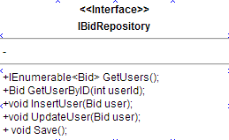
Methods
ID | Name | Description | Remark
1 | GetUsers() | The System use this method from Repository | returnType:  Parameter:
2 | InsertUser(Bid user) | The System use this method from Repository | returnType:  Parameter: Bid user
3 | UpdateUser(Bid user) | The System use this method from Repository | returnType:  Parameter: Bid user
4 | Save() | The System use this method from Repository | returnType:  Parameter:
5 | GetUserByID(int userId) | The System use this method from Repository | returnType:  Parameter: int userId

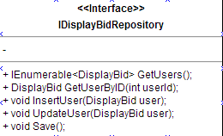
Methods
ID | Name | Description | Remark
1 | GetUsers() | The System use this method from Repository | returnType:  Parameter:
2 | InsertUser(DisplayBid user) | The System use this method from Repository | returnType:  Parameter: DisplayBid user
3 | UpdateUser(DisplayBid user) | The System use this method from Repository | returnType:  Parameter: DisplayBid user
4 | Save() | The System use this method from Repository | returnType:  Parameter:
5 | GetUserByID(int userId) | The System use this method from Repository | returnType:  Parameter: int userId

3.2.3 Model Class Description
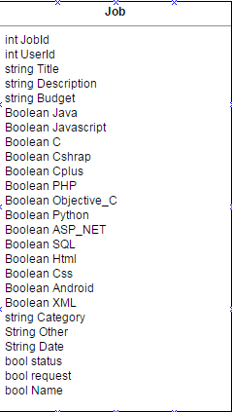

Property
ID | Name | Description | Remark
1 | JobId | Automate Value to set id of job | Type: int
2 | UserId | Automate Value to set id of user | Type: int
3 | Title | Value set for retrieve job Title | Type: string
4 | Description | Value set for retrieve job Description | Type: string
5 | Budget | Value set for retrieve budget of job | Type: Budget
6 | Java | Value set for retrieve software skill job in type Java | Type: Boolean
7 | Javascript | Value set for retrieve software skill job in type Javascript | Type: Boolean
8 | C | Value set for retrieve software skill job in type C | Type: Boolean
9 | Csharp | Value set for retrieve software skill job in type Csharp | Type: Boolean
10 | Cplus | Value set for retrieve software skill job in type Cplus | Type: Boolean
11 | PHP | Value set for retrieve software skill job in type PHP | Type: Boolean
12 | Objective_C | Value set for retrieve software skill job in type Objective_C | Type: Boolean
13 | Python | Value set for retrieve software skill job in type Python | Type: Boolean
14 | ASP_NET | Value set for retrieve software skill job in type ASP_NET | Type: Boolean
15 | SQL | Value set for retrieve software skill job in type SQL | Type: Boolean
16 | Html | Value set for retrieve software skill job in type Html | Type: Boolean
17 | CSS | Value set for retrieve software skill job in type CSS | Type: Boolean
18 | Android | Value set for retrieve software skill job in type Android | Type: Boolean
19 | XML | Value set for retrieve software skill job in type XML | Type: Boolean
20 | Category | Value set for retrieve software role type | Type: string
21 | Other | Value set for retrieve other skill | Type: string
22 | Date | Value set for show date of job | Type: string
23 | Status | Value set status of job | Type: Boolean
24 | request | Value set for request job | Type: Boolean
25 | name | Value set for job name | Type: Boolean
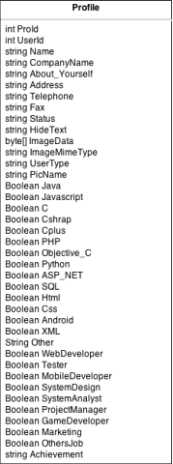

Property
ID | Name | Description | Remark
1 | ProId | Automate Value to set id of Profile | Type: int
2 | UserId | Automate Value to set id of UserId | Type: int
3 | Name | Value set for retrieve Name of User | Type: string
4 | CompanyName | Value set for retrieve CompanyName of User | Type: string
5 | About_Yourself | Value set for retrieve About_Yourself of User | Type: string
6 | Address | Value set for retrieve Address of User | Type: string
7 | Telephone | Value set for retrieve Telephone of User | Type: string
8 | Fax | Value set for retrieve Fax of User | Type: string
9 | Status | Value set for retrieve Status of User | Type: string
10 | HideText | Value set for HideText from User | Type: string
11 | ImageData | Value set for retrieve ImageData of User | Type: byte[]
12 | ImageMimeType | Value set for retrieve ImageMimeType of User | Type: string
13 | UserType | Value set for retrieve UserType of User | Type: string
14 | PicName | Value set for retrieve PicName of User | Type: string
15 | Java | Value set for retrieve software skill job in type Java | Type: Boolean
16 | Javascript | Value set for retrieve software skill job in type Javascript | Type: Boolean
17 | C | Value set for retrieve software skill job in type C | Type: Boolean
18 | Csharp | Value set for retrieve software skill job in type Csharp | Type: Boolean
19 | Cplus | Value set for retrieve software skill job in type Cplus | Type: Boolean
20 | PHP | Value set for retrieve software skill job in type PHP | Type: Boolean
21 | Objective_C | Value set for retrieve software skill job in type Objective_C | Type: Boolean
22 | Python | Value set for retrieve software skill job in type Python | Type: Boolean
23 | ASP_NET | Value set for retrieve software skill job in type ASP_NET | Type: Boolean
24 | SQL | Value set for retrieve software skill job in type SQL | Type: Boolean
25 | Html | Value set for retrieve software skill job in type Html | Type: Boolean
26 | CSS | Value set for retrieve software skill job in type CSS | Type: Boolean
27 | Android | Value set for retrieve software skill job in type Android | Type: Boolean
28 | XML | Value set for retrieve software skill job in type XML | Type: Boolean
29 | Other | Value set for retrieve other skill | Type: string
30 | WebDeveloper | Value set for retrieve software role job in type WebDeveloper | Type: Boolean
31 | Tester | Value set for retrieve software role job in Tester | Type: Boolean
32 | MobileDeveloper | Value set for retrieve software role job in MobileDeveloper | Type: Boolean
33 | SystemDesign | Value set for retrieve software role job in SystemDesign | Type: Boolean
34 | SystemAnalyst | Value set for retrieve software role job in SystemAnalyst | Type: Boolean
35 | ProjectManager | Value set for retrieve software role job in ProjectManager | Type: Boolean
36 | GameDeveloper | Value set for retrieve software role job in GameDeveloper | Type: Boolean
37 | Marketing | Value set for retrieve software role job in Marketing | Type: Boolean
38 | OthersJob | Value set for retrieve software role job in type OthersJob | Type: Boolean
39 | Achievment | Value set for display achievement title name | Type: String

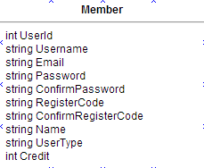
Property
ID | Name | Description | Remark
1 | UserId | Automate Value to set id of User | Type: int
2 | Username | Value to retrive and set Username from User | Type: string
3 | Email | Value to retrive and set Email from User | Type: string
4 | Password | Value to retrive and set Password from User | Type: string
5 | ConfirmPassword | Value to retrive ConfirmPassword from User | Type: string
6 | RegisterCode | Value set for RegisterCode to User | Type: string
7 | ConfirmRegisterCode | Value retrieve ConfirmRegisterCode from User | Type: string
8 | UserType | Value set Type of User | Type: string
9 | Status | Value set status of User | Type: string
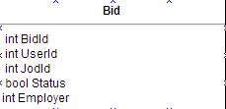
Property
ID | Name | Description | Remark
1 | BidId | Automate Value to set id of Bid | Type: int
2 | UserId | Automate Value to set id of User | Type: int
3 | JobId | Automate Value to set id of Job | Type: int
4 | Status | Value to check status of bid | Type: bool

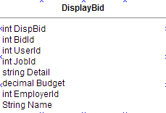
Property
ID | Name | Description | Remark
1 | DispBid | Automate Value to set id of Bidlist | Type: int
2 | BidId | Automate Value to set id of Bid | Type: int
3 | UserId | Automate Value to set id of User | Type: int
4 | JobId | Automate Value to set id of Job | Type: int
5 | Detail | Value set to retrieve detail for Bid | Type: string
6 | Budget | Value set to retrieve Budget for Bid | Type: Budget
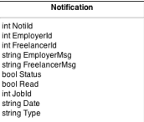

Property
ID | Name | Description | Remark
1 | NotiId | Automate Value to set id of Notification | Type: int
2 | EmployerId | Automate Value to set id of Employer Notification | Type: int
3 | FreelancerId | Automate Value to set id of Freelancer Notification | Type: int
4 | EmployerMsg | Automate Value to set message to send | Type: string
5 | FrelancerMsg | Value set to set message to send | Type: string
6 | Status | Value set to set status of Notification | Type: boolean
7 | Read | Value set to set status that read or not | Type: boolean
8 | JobId | Value set to set status number of job to request | Type: int
9 | Date | Value set to set date of notification | Type: string
10 | Type | Value set to set type of skill or job | Type: string
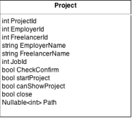
Property
ID | Name | Description | Remark
1 | ProjectId | Automate Value to set id of project | Type: int
2 | EmployerId | Automate Value to set id of Employer in project | Type: int
3 | FreelancerId | Automate Value to set id of Freelancer in project | Type: int
4 | EmployerName | Value to set name of employer name in project | Type: string
5 | FreelancerName | Value to set name of freelancer name in project | Type: string
6 | JobId | Value set to set Id of job in project | Type: int
7 | CheckConfirm | Value set to set status of confirm project | Type: boolean
8 | startProject | Value set to set status project to start task | Type: boolean
9 | canShowProject | Value set to set status to show project | Type: boolean
10 | close | Value set to set close project | Type: boolean
11 | Path | Value set path of folder in server | Type: int
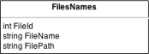

Property
ID | Name | Description | Remark
1 | FileId | Automate Value to set id of file | Type: int
2 | FileName | Value to set name of file | Type: string
3 | FilePath | Value to set number of filepath | Type: string

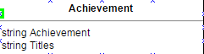
Property
ID | Name | Description | Remark
1 | Achievement | Value to set display achievement in profile | Type: string
2 | Titles | Value to set titles of achievement | Type: string
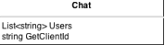

Property
ID | Name | Description | Remark
1 | Users | Value to set list of user in chat | Type: string
2 | GetclientId | Value to set Id of clients | Type: string

3.3 Sequence Diagram
Sequence diagram separated into two user in 3 user that is service request customer, freelancer supply and Guest Sequence Diagram will separate following group of the user of WebApplication ID of sequence diagram will follow this

If Sequence diagram related with Service request customer user-type, Sequence diagram will be format like this - E – SQD – [Number of Sequence diagram]
(EX E-SQD-01: Register for service request customer)
If Sequence diagram related with freelancer supply user-type, Sequence diagram will be format like this - F – SQD – [Number of Sequence diagram]
(EX F-SQD-01: Register for Freelancer supply)

3.3.1 Service request customer

E-SQD-01: Register for service request customer

E-SQD-02: Confirm Register for service request customer

E-SQD-03: Login for service request customer

E-SQD-04: Add&Edit Profile for service request customer

E-SQD-05: Logout for service request customer

E-SQD-06:Request password for service request customer

E-SQD-07: Post Project for service request customer

E-SQD-08: See freelancer for service request customer

E-SQD-09: service request customer can view project list in system

E-SQD-10: service request customer can view list of bidding below project

E-SQD-11: service request customer can request freelancer in list

E-SQD-12: Service request customer can view successes project in Freelance supply profile.

E-SQD-13: can search job list in service request customer management Page

E-SQD-14: Service request customer can view confirm freelancer list that accept to do project

E-SQD-15: Service request customer can remove posted job

E-SQD-16: Service request customer can view notification that get from freelancer to confirm to do project

E-SQD-17: Service request customer can remove notification message

E-SQD-18: Service request customer start project management process task.

E-SQD-19: Service request customer view list of project that are in processing.

E-SQD-20: Service request customer can uploadfile in project management process

E-SQD-21: Service request customer can downloadfile in project management process.

E-SQD-22: Service request customer can chat with other in project management process.
.

E-SQD-23: Service request customer view online status in number in project management process

E-SQD-24: Service request customer can closed project management process

3.3.2 Freelancer supply

F-SQD-01: Register for freelance supply

F-SQD-02: Confirm Register for freelance supply

F-SQD-03: Login for freelance supply

F-SQD-04: Add&Edit Profile for freelance supply

F-SQD-05: Logout for freelancer supply

F-SQD-06: Request password for freelance supply

F-SQD-07: Freelancer supply view list of project that they done in their profile.

F-SQD-08: Freelance supply search job list in Freelancer supply management Page

F-SQD-09: Freelance supply bidding job by input bid detail and require budget

F-SQD-10: Freelance supply view list of notification that came from the service request customer

F-SQD-11: Freelance supply delete of notification that came from the service request customer

F-SQD-12: Freelance supply have consider to accept job required from Service request customer

F-SQD-13: Freelance supply view bid detail and required budget of other freelancer supply that interest to do project

F-SQD-14: Freelance supply view Freelancer that accept by Service request customer to do project.

F-SQD-15: Freelance supply view list of project that are in processing.

F-SQD-16: Freelance supply uploadfile in project management process

F-SQD-17: Freelance supply downloadfile in project management process

F-SQD-18: Freelance supply chat with other people in project management process

F-SQD-19: Freelance supply view number of people that online in project management process

3.3.3 Guest

G-SQD-01: Register for Guest

Chapter Four | Data Architecture

4.1 DB Design
DB 01 - Member
Field | Type | AllowNull
UserId | int
Username | nchar(20)
Email | nchar(50)
Password | nchar(20)
ConfirmPassword | nchar(20)
RegisterCode | nchar(20)
ConfirmRegisterCode | nchar(20)
Name | nchar(20)
UserType | nchar(20)
Credit | int

DB 02 - Profile
Field | Type | AllowNull
ProId | int
UserId | int
Name | nchar(50)
UserType | nchar(20)
CompanyName | nchar(30)
About_Yourself | nchar(200)
Address | nchar(300)
Telephone | nchar(10)
Fax | nchar(10)
Status | nchar(30)
HideText | nchar(10)
PicName | nchar(50)
ImageData | varbinary(max)
ImageMimeType | varchar(50)
Java | bit
JavaScript | bit
C | bit
CSharp | bit
Cplus | bit
PHP | bit
Objecttive-C | bit
Python | bit
ASP.NET | bit
Ruby | bit
SQL | bit
Android | bit
XML | bit
Others | nchar(150)
WebDeveloper | bit
Tester | bit
MoblieDeveloper | bit
SystemDesign | bit
SystemAnalysist | bit
ProjectManager | bit
GameDeveloper | bit
Marketing | bit
OtherJob | bit

DB 03 - Job
Field | Type | AllowNull
JobId | int
UserId | int
Title | nchar(30)
Descliption | nchar(800)
IntitialBudget | decimal(16,2)
finalBudget | decimal(16,2)
Java | bit
JavaScript | bit
C | bit
CSharp | bit
Cplus | bit
PHP | bit
Objecttive-C | bit
Python | bit
ASP.NET | bit
Ruby | bit
SQL | bit
Android | bit
XML | bit
Category | nchar(25)
Other | nchar(100)
Date | nchar(300)
Status | bit
Request | bit

DB 04 - Bid

Field | Type | AllowNull
BidId | Int
EmployerId | Int
UserId | Int
JobId | Int
Status | Bit

DB 05 - DisplayBid

Field | Type | AllowNull
DispBidId | Int
EmployerId | Int
BidId | Int
UserId | Int
JobId | Int
Detail | nchar(50)
Budget | decimal(16,2)
Name | nchar(50)

DB 06 - Notification

Field | Type | AllowNull
NotiId | Int
JobId | Int
EmployerId | Int
FreelancerId | Int
EmployerMsg | nchar(100)
FreelancerMsg | nchar(50)
Status | Bit
Read | Bit
Date | nchar(20)
Type | nchar(10)

DB 07 - Project

Field | Type | AllowNull
ProjectId | Int
JobId | Int
EmployerId | Int
FreelancerId | Int
EmployerMsg | nchar(100)
FreelancerMsg | nchar(50)
CheckConfirm | Bit
Path | Int

Chapter Five | User Interface Design

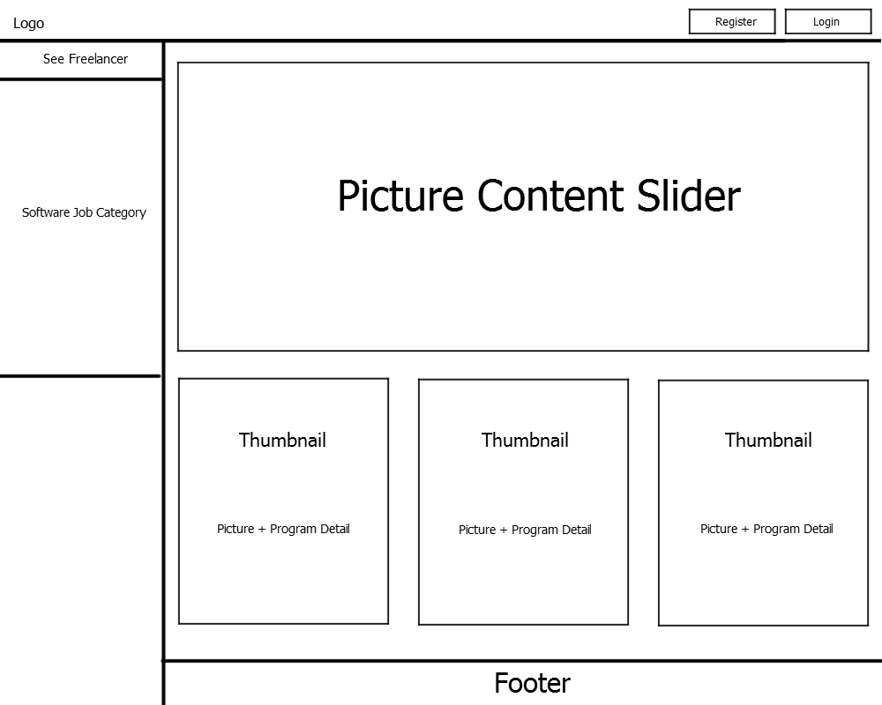
UID 01 – HomePage

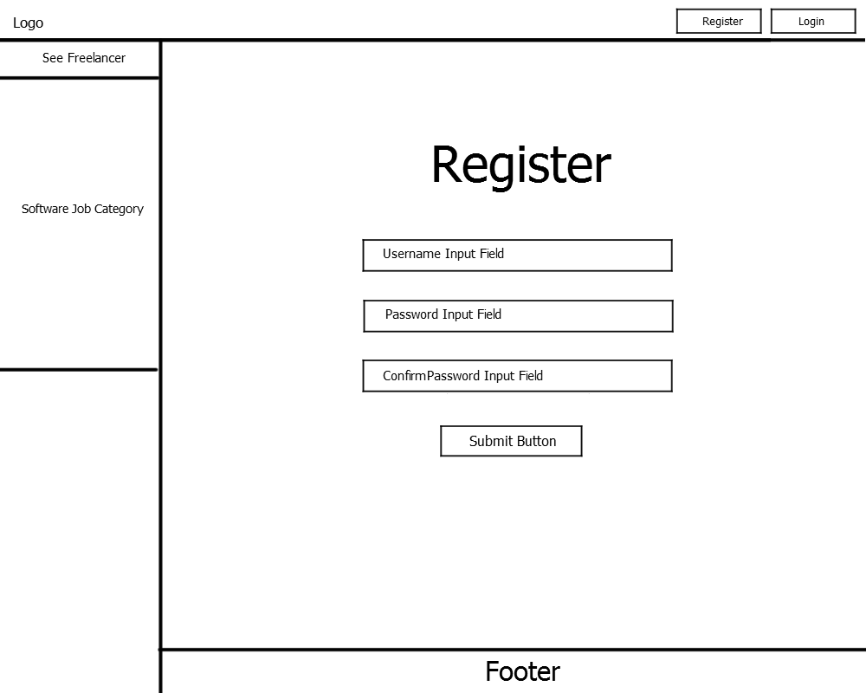
UID 02 - Register
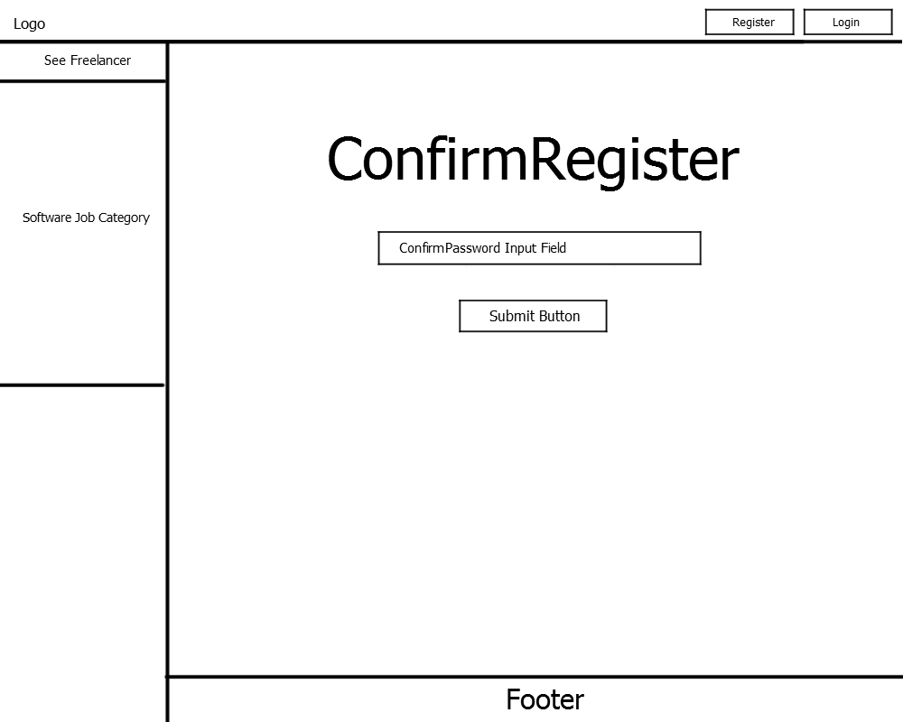
UID 03 – ConfirmRegister
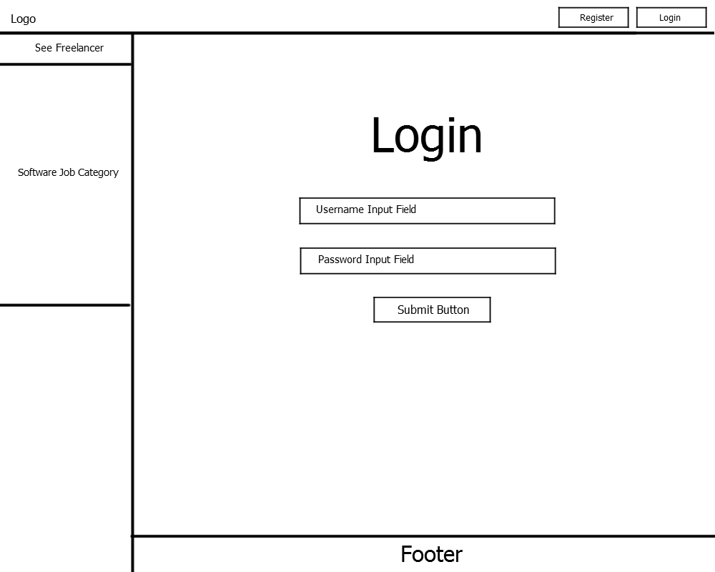
UID 04 – Login
Are you Forget Password?
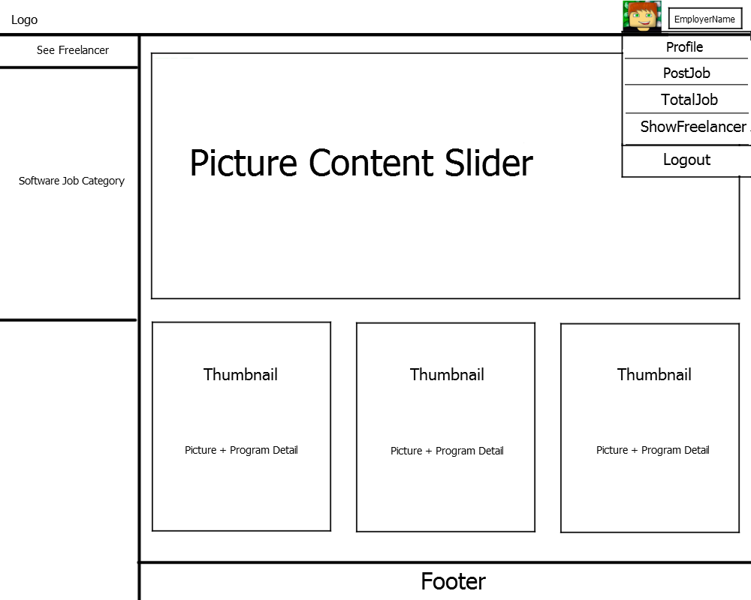
UID 05 – EmployerMainPage

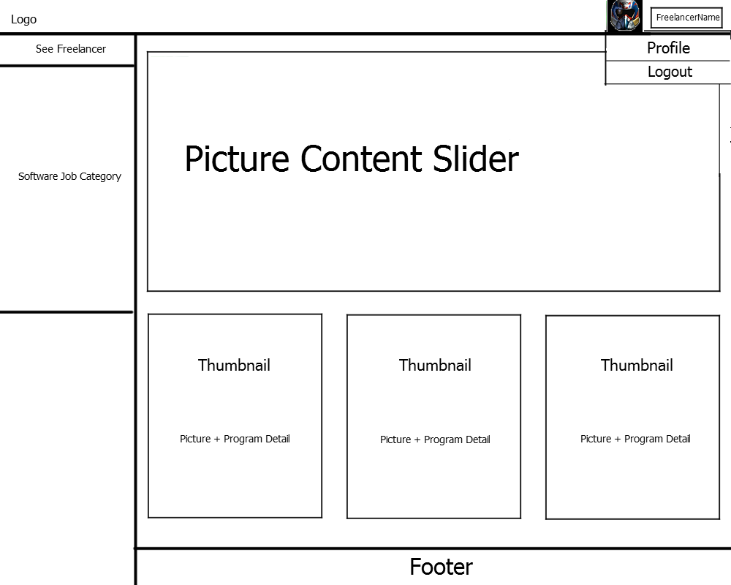
UID 06 – FreelancerMainPage

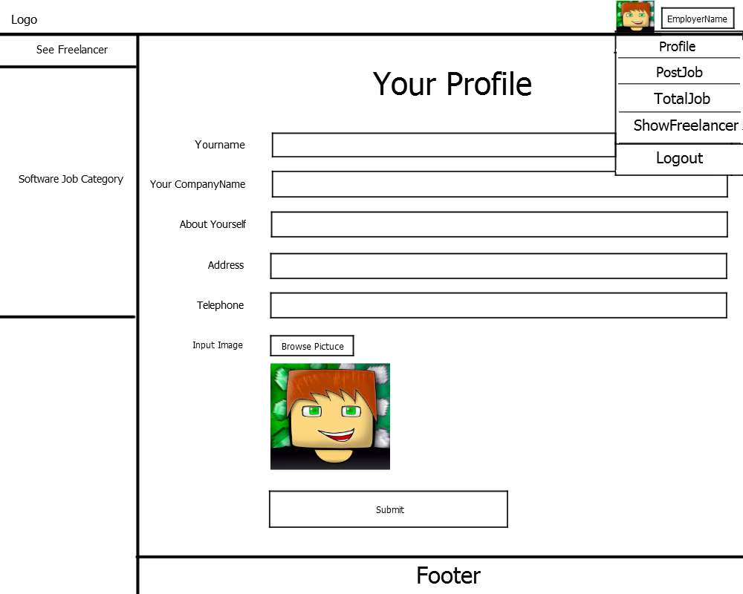
UID 07 – EmployerProfile

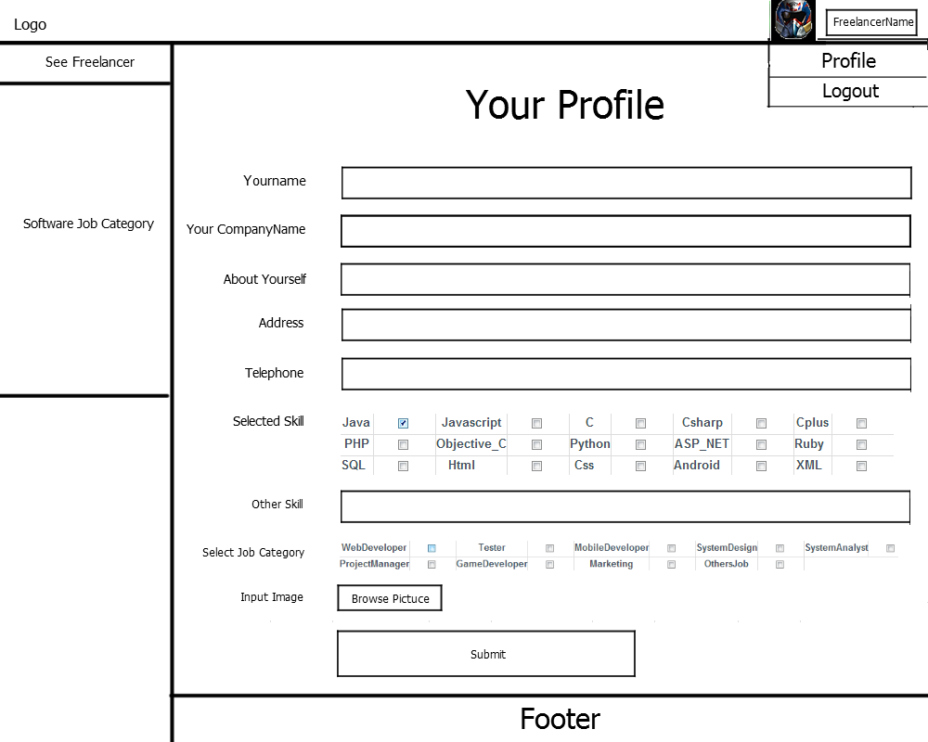
UID 08 – FreelancerProfile

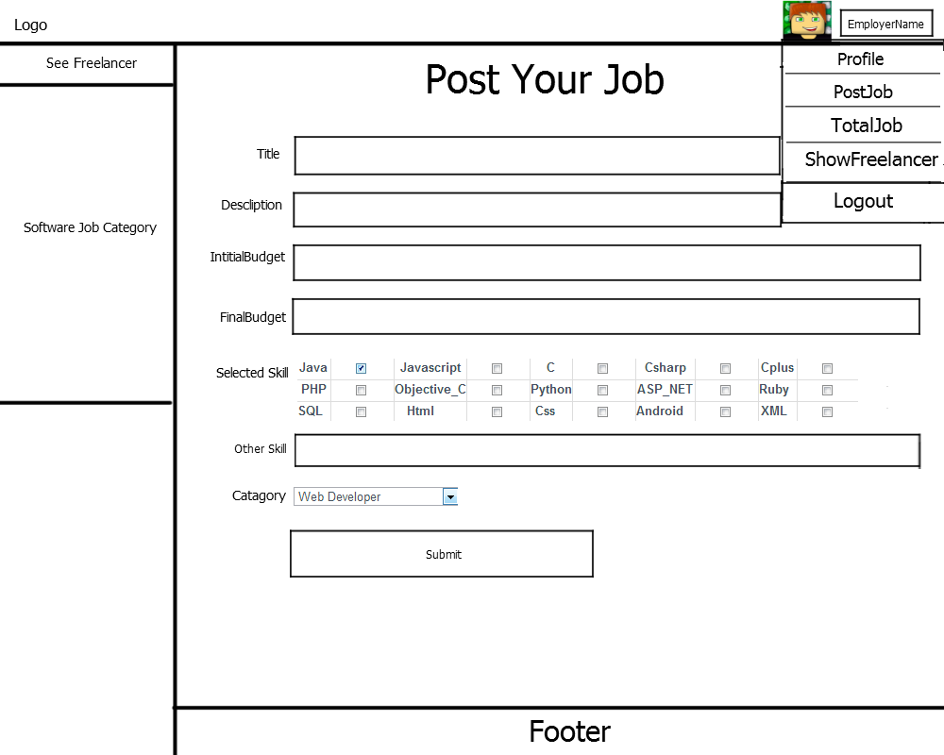
UID 09 – PostJob

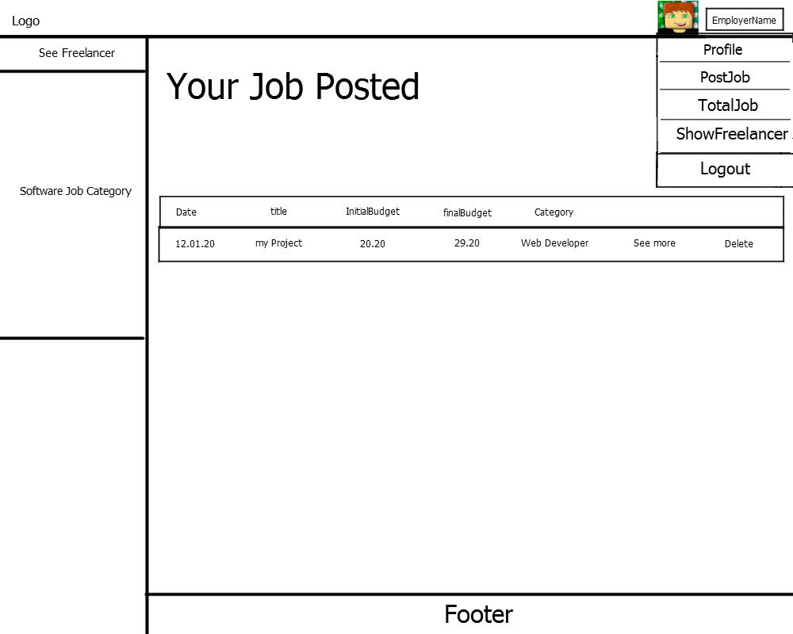
UID 10 – TotalJob

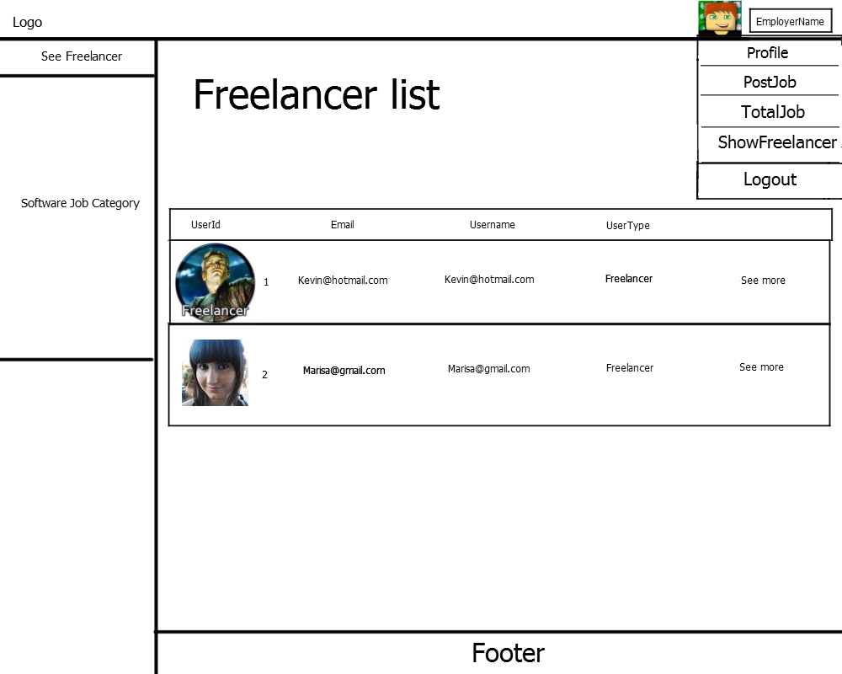
UID 11 – Show Freelancer list

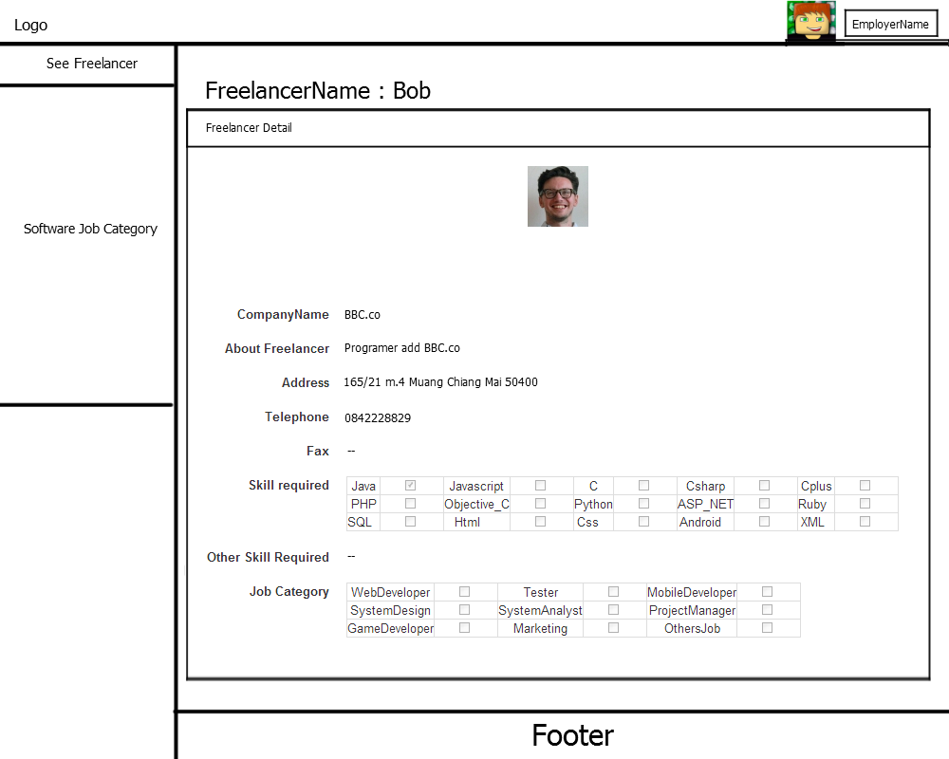
UID 12 – Show Freelancer Detail

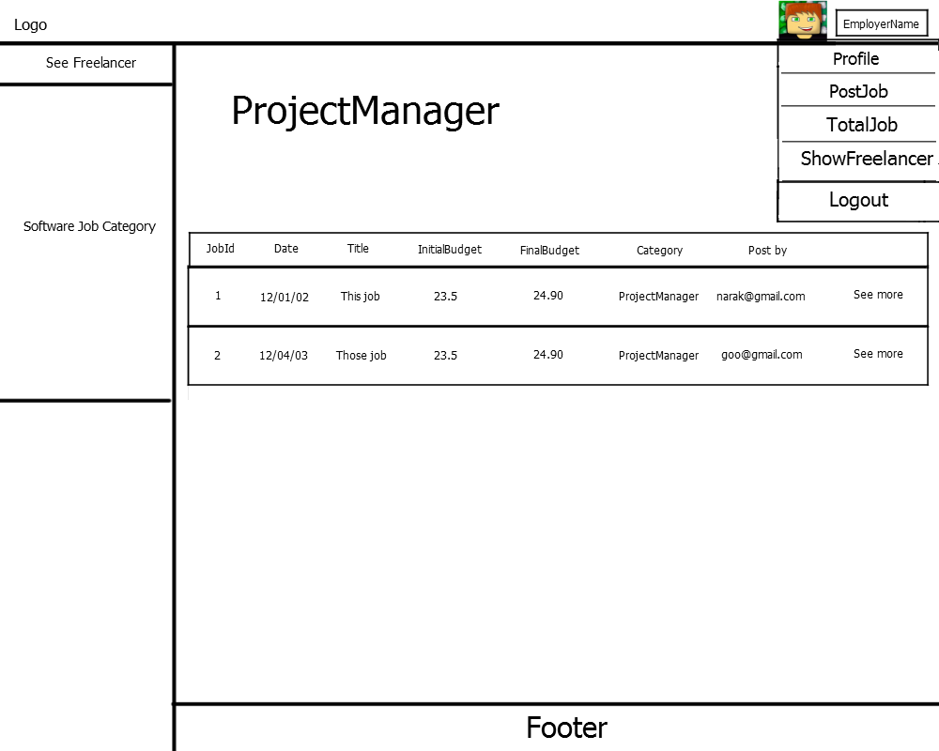
UID 13 – Show Job list

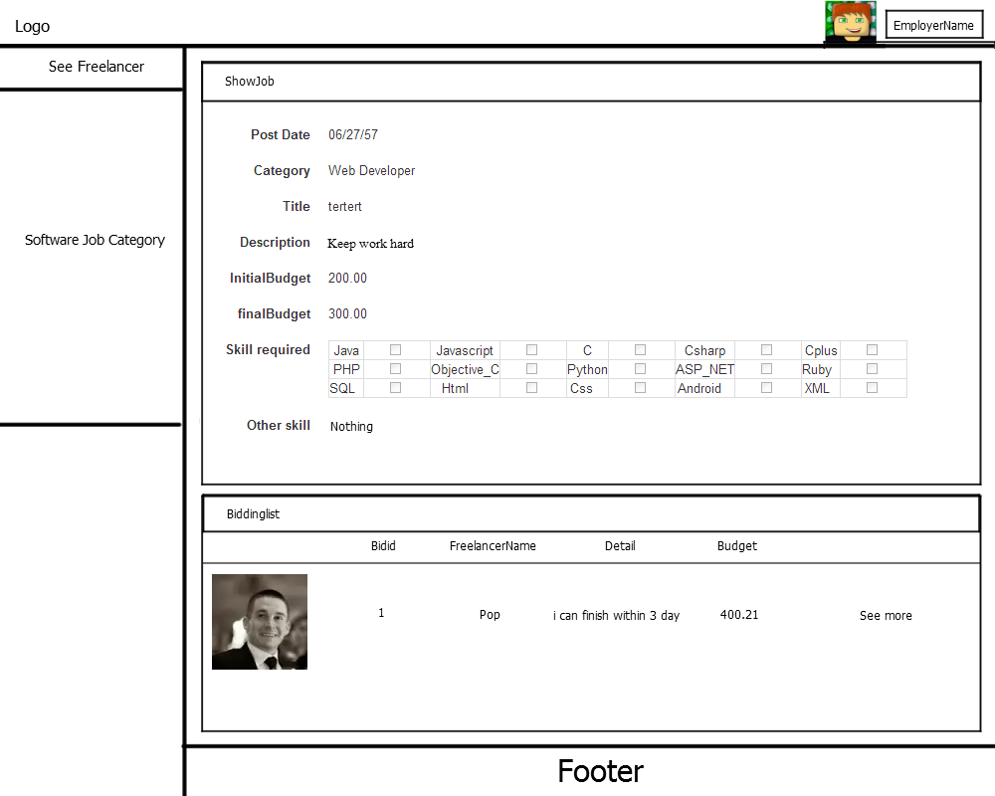
UID 14 – Show Job Detail

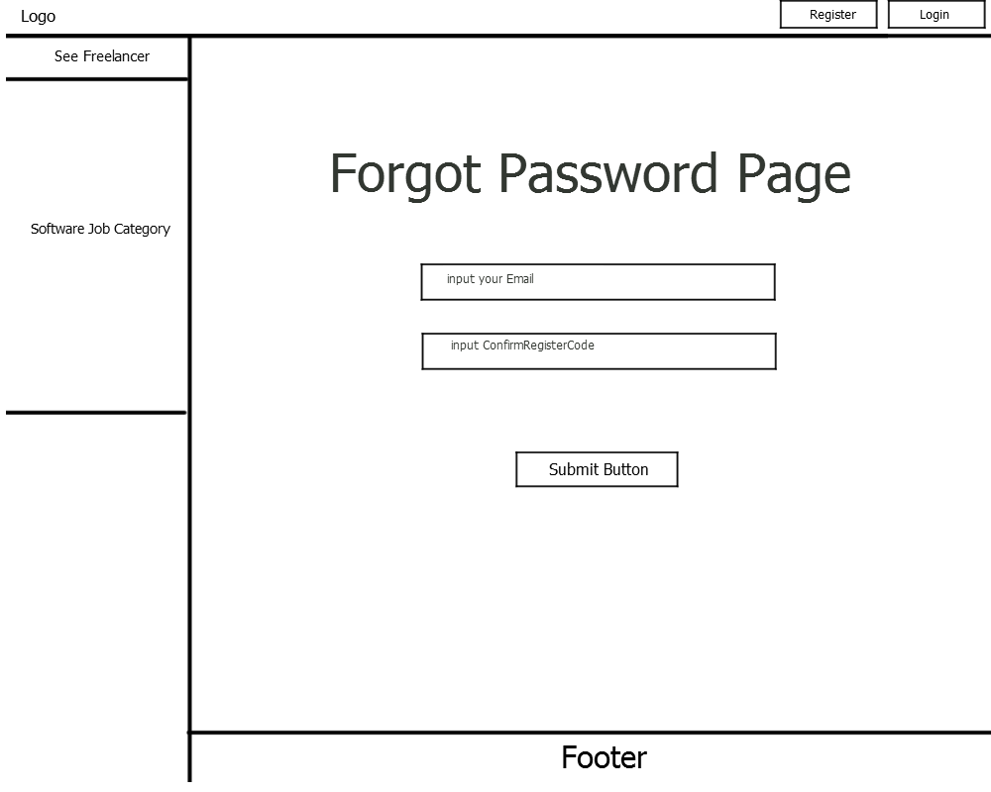
UID 15 – Forgot password

